AI POWERED CROP DISEASE DETECTION AND RECOMMENDATION SYSTEM FOR SUSTAINABLE DEVELOPMENT
Methodology, Novelty and Key Contributions
Department of Computer Science and Engineering, [COLLEGE NAME]
Batch C16 (CSE-C) · Academic year [ACADEMIC YEAR]
Table 1: Project team
S.No. | Student name | Roll number
1 | Pishke Vishal | 23K91A05J2
2 | Kyatham Nithisha | 23K91A05D1
3 | Mekala Tharun Kuruma | 23K91A05F1
4 | Nakka Sreenith | 23K91A05H0

Project guide: V Krishna Teja
Chapter and section numbers quoted in the text (for example Chapter 8 or Section 6.2) refer to the full project report, 17.Final Document. Figures and tables in this document are numbered from 1.

1. METHODOLOGY
This document describes how AgriVision works from end to end and what is new in it. Part 1 gives the pipeline, the data, the algorithms and the reasons they were chosen; Part 2 sets the work against the base paper and separates what is new from what is standard; Part 3 lists the contributions.

1.1 Overall methodology
The work has two parts that meet at one function. The first part is a web application that accepts a leaf photograph and a crop, asks inference.predict() for the three most likely classes, turns the top class into advice with the knowledge base and keeps a history for the user. The second part is an offline study that measures how well engines of increasing strength can do the job that predict() is meant to do, on one public field-photograph benchmark and under one protocol. The study was necessary because the product, as inherited, contained no trained network and no measurement of any kind.
1. Data. Take the PlantDoc images as released (2,342 training and 236 test photographs), map their 28 folder names to the 38-class label set of the knowledge base.
2. Pre-processing. Resize (256 x 256 for the heuristic, 224 x 224 for networks), scale pixel values, and, for training only, augment with flips, small rotations, zoom and contrast changes.
3. Engines. (a) The shipped colour and texture heuristic; (b) the compact depthwise-separable CNN of train.py; (c) a MobileNetV2 with ImageNet weights, head trained then top layers fine-tuned; (d) a random forest and a logistic regression on hand-made colour and texture features.
4. Protocol. 10 % stratified validation split from the training folder for early stopping, three seeds, the test folder touched only for the final scores; five hash seeds for the heuristic.
5. Metrics. Accuracy, top-3 accuracy, macro-F1, per-class precision, recall and F1, confusion matrix, crop-level and healthy-versus-diseased accuracy, CPU latency.
6. Advice. The predicted class selects a knowledge-base card: symptoms, lifecycle, severity, three treatments (chemical, organic, cultural) and prevention, shown in the interface language chrome.
7. Application. FastAPI over the original modules, React front end, SQLite history, CSV and PDF reports, dashboard and analytics.

1.2 Dataset
PlantDoc [4] is a set of web-scraped photographs of diseased and healthy leaves taken in real conditions: mixed backgrounds, hands, soil, several leaves per photograph and widely varying resolution (189 to 4,000 pixels wide). It is released under CC-BY-4.0. The copy used here is the HF mirror geraldmc/plantdoc-full, stored as folders in datasets/plantdoc-images (445 MB, not committed). It holds 2,342 training and 236 test photographs in 28 class folders; the test folder has 27 classes because Tomato_two_spotted_spider_mites_leaf has two training photographs and none for testing. Ten folders are healthy leaves (90 test photographs) and 18 are diseases (146 test photographs, 61.9 %).
Table 2: PlantDoc class sizes (train and test photographs per folder)
Class folder | Train | Test | Class folder | Train | Test
Apple Scab Leaf | 83 | 10 | Soyabean | 57 | 8
Apple | 82 | 9 | Squash Powdery mildew | 124 | 6
Apple rust | 79 | 10 | Strawberry | 88 | 8
Bell pepper | 53 | 8 | Tomato Early blight | 79 | 9
Bell pepper spot | 62 | 9 | Tomato Septoria spot | 140 | 11
Blueberry | 106 | 11 | Tomato | 55 | 8
Cherry | 47 | 10 | Tomato bacterial spot | 101 | 9
Corn Gray spot | 64 | 4 | Tomato late blight | 101 | 10
Corn blight | 180 | 12 | Tomato mosaic virus | 44 | 10
Corn rust | 106 | 10 | Tomato yellow virus | 70 | 6
Peach | 103 | 9 | Tomato mold | 85 | 6
Potato early blight | 109 | 8 | Tomato two spotted spider mites | 2 | 0
Potato late blight | 97 | 8 | grape | 57 | 12
Raspberry | 112 | 7 | grape black rot | 56 | 8

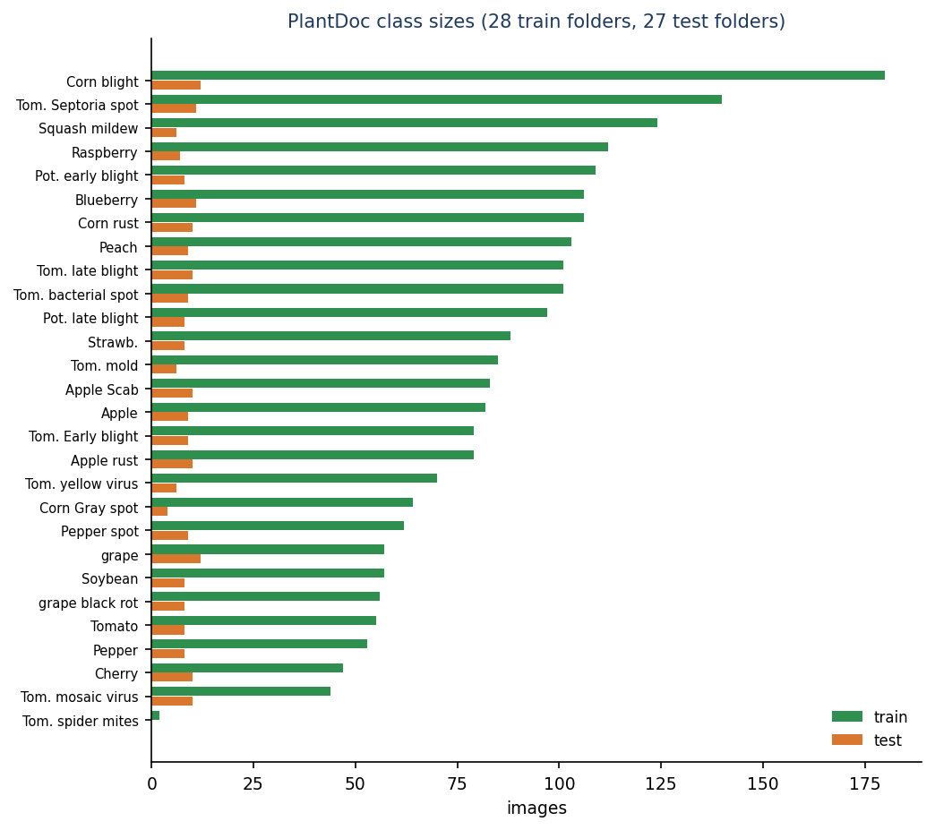
Figure 1: Number of photographs per PlantDoc class in the train and test folders.
The data are small and unbalanced (two to 180 training photographs per class; Corn leaf blight is the largest test class with 12 photographs, 5.1 %), which limits every number in this report. Class names are not the 38 labels of the application: PLANTDOC_MAP in inference.py maps each of the 28 folders to one canonical label (for example Tomato_leaf_late_blight to Tomato___Late_blight). The mapping is one-to-one, so ten canonical classes (such as Apple black rot, Grape esca and Tomato target spot) have no PlantDoc photograph at all and can never be scored as correct in the study.

1.3 Pre-processing

1.3.1 Heuristic engine
The heuristic converts the image to RGB, resizes it to 256 x 256 and scales pixels to [0, 1] with r, g, b the channels. It then measures six numbers on the whole picture: the share of green pixels (g > r + 0.03 and g > b + 0.01), brown pixels (r > 0.35, 0.15 < g < 0.55, r - g > 0.08), yellow pixels (r > 0.5, g > 0.5, b < 0.4), dark pixels (mean of the three channels below 0.25), white pixels (minimum of the three channels above 0.72) and the standard deviation of all values. Nothing is learnt: the thresholds were chosen by hand.
def _features(img: Image.Image) -> dict:
img = img.convert("RGB").resize((256, 256))
a = np.asarray(img).astype(np.float32) / 255.0
r, g, b = a[..., 0], a[..., 1], a[..., 2]
green_mask = (g > r + 0.03) & (g > b + 0.01)
green_ratio = float(green_mask.mean())
brown = ((r > 0.35) & (g < 0.55) & (g > 0.15) & (r > g) & ((r - g) > 0.08)).mean()
yellow = ((r > 0.5) & (g > 0.5) & (b < 0.4)).mean()
dark = (a.mean(axis=-1) < 0.25).mean()
white = (a.min(axis=-1) > 0.72).mean()
var = float(a.std())
return dict(green=green_ratio, brown=float(brown), yellow=float(yellow),
dark=float(dark), white=float(white), var=var)

1.3.2 Training pipeline
For the networks, run_experiments.py data decodes every photograph once with Pillow (the draft option makes large JPEG files quick), converts to RGB, resizes to 224 x 224 with bilinear interpolation, and stores the result as an unsigned 8-bit array in cache224.npz. Labels are the folder indices of the 28 training folders. The stratified validation split takes round(0.10 n) photographs from every class that has at least five (none from the two-photograph class), for each seed separately. Augmentation is part of the network, so it is active only during training:
Table 3: Augmentation layers
Layer | Setting | Used by
RandomFlip | horizontal | compact CNN, MobileNetV2
RandomRotation | factor 0.08 (up to about 29 degrees either way) | compact CNN, MobileNetV2
RandomZoom | factor 0.1 | compact CNN, MobileNetV2
RandomContrast | factor 0.1 | compact CNN only
Rescaling | 1/255 (CNN) or 1/127.5 - 1 (MobileNetV2) | both

1.3.3 Hand-made features for the classical baselines
The random forest and the logistic regression see 43 numbers per photograph: a 16-bin hue histogram, an 8-bin saturation histogram and an 8-bin value histogram (32 numbers), the mean and standard deviation of the grey level and of the Sobel gradient magnitude and the share of strong gradients (5 numbers), and the mean and standard deviation of each RGB channel (6 numbers).

1.4 Algorithm choice and justification
Table 4: Engines compared and why each is in the study
Engine | What it is | Why it is here
Heuristic (shipped) | Hand-written scores on six colour and texture shares; no training | It is what the product actually runs. Measuring it is the only honest way to report the system's accuracy.
Compact CNN of train.py (189,655 parameters) | Five depthwise-separable convolution blocks, batch normalisation, global average pooling, dense head | It is the model the original product intended to ship; separable convolutions [10] keep it small enough for CPU training. Its recipe is measured exactly as written.
MobileNetV2 (2,293,852 parameters) | ImageNet-pre-trained inverted-residual network, new 28-way head, top 30 layers fine-tuned | PlantDoc is small; transfer learning from ImageNet [13] is the standard remedy and MobileNetV2 [9] is light enough for a phone or a laptop CPU. It shows what the data can support.
Random forest and logistic regression | Classical classifiers on 43 hand-made features | A cheap, interpretable yardstick [18]: any network should beat colour and texture statistics learnt from the data, and the hand-set heuristic should not lose to them.

Heavier networks (ResNet, EfficientNet, vision transformers) were not trained: the aim was an engine that runs in about a second on the machine that serves the application, and the comparison already shows that the limiting factor is the data, not the backbone. The base paper's own models (VGG19, ResNet50, DenseNet121, Swin, CBAM-ConvNeXt) need GPUs of the class used in that paper [1] and are outside the compute available here.

1.5 Model architecture and training configuration

1.5.1 Compact CNN of train.py
Table 5: Layers of the compact CNN (input 224 x 224 x 3, 28 outputs)
Layer | Output size | Parameters
Rescaling 1/255 + augmentation | 224 x 224 x 3 | 0
SeparableConv2D 32, 3x3, stride 2, ReLU | 112 x 112 x 32 | 155
BatchNorm, MaxPool 2, Dropout 0.15 | 56 x 56 x 32 | 128
SeparableConv2D 64, stride 1, ReLU | 56 x 56 x 64 | 2,400
BatchNorm, MaxPool 2, Dropout 0.15 | 28 x 28 x 64 | 256
SeparableConv2D 128, stride 2, ReLU | 14 x 14 x 128 | 8,896
BatchNorm, MaxPool 2, Dropout 0.15 | 7 x 7 x 128 | 512
SeparableConv2D 256, stride 2, ReLU | 4 x 4 x 256 | 34,176
BatchNorm, MaxPool 2, Dropout 0.15 | 2 x 2 x 256 | 1,024
SeparableConv2D 256, stride 1, ReLU | 2 x 2 x 256 | 68,096
BatchNorm, MaxPool 2, Dropout 0.15 | 1 x 1 x 256 | 1,024
GlobalAveragePooling, Dropout 0.3 | 256 | 0
Dense 256, ReLU | 256 | 65,792
Dense 28, softmax | 28 | 7,196
Total |  | 189,655

The measured size is 189,655 parameters (about 2.4 MB as a .keras file), not the 'about 1.1 M' written in the docstring of train.py (defect D6). The comparable network PD36-C [2] has 1,250,694 parameters. Its last feature map is only 1 x 1, so spatial detail is discarded early: five max-pooling layers follow five strided or unstrided convolutions.

1.5.2 Training configurations
Table 6: Training configuration of every trained model
Item | Compact CNN | MobileNetV2
Input | 224 x 224 RGB, uint8 cache | 224 x 224 RGB, uint8 cache
Loss | sparse categorical cross-entropy | sparse categorical cross-entropy
Optimiser | Adam, learning rate 1e-3, ReduceLROnPlateau (factor 0.5, patience 2, on validation loss) | Adam 1e-3 for the head (up to 20 epochs), then Adam 1e-4 with the top 30 backbone layers unfrozen (up to 12 epochs)
Batch size | 32 | 32
Epochs (maximum) | 60; the shipped-protocol and tuned variants use 60 and 100 | 20 + 12
Early stopping | validation accuracy, patience 8, restore best weights | validation accuracy, patience 4 (head) and 3 (fine-tune), restore best
Validation | 10 % stratified split of the training folder | same split for the same seed
Seeds | 42, 43, 44 | 42, 43, 44
Regularisation | dropout 0.15 and 0.3, batch normalisation, augmentation | dropout 0.3, augmentation
Hardware | CPU only (i5-12500); other jobs shared the CPU | same

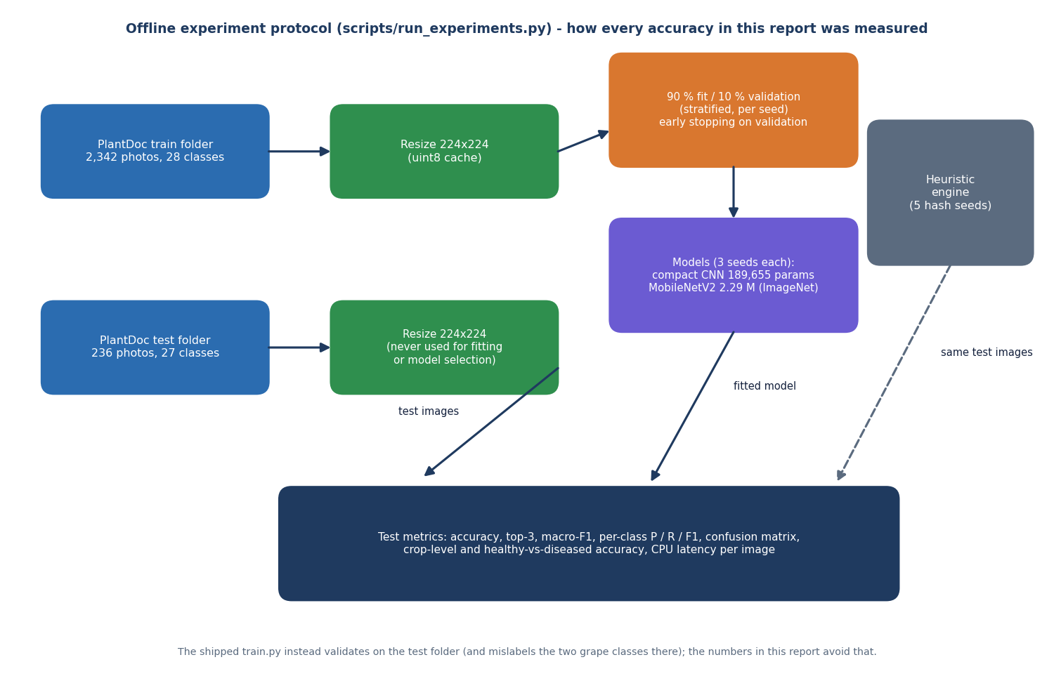
Figure 2: Offline experiment protocol: the test folder is used only for the final scores.

1.5.3 Classical baselines and the heuristic
The random forest has 300 trees with balanced class weights and seed 42; the logistic regression uses standardised features, C = 1 and up to 3,000 iterations. The heuristic needs no training; its hash-seeded jitter depends on Python's PYTHONHASHSEED, so it was evaluated with five values (0 to 4), and the value 0 used by run.bat is reported separately.

1.6 Mathematical formulation
Heuristic score. With g, b, y, d, w the shares of green, brown, yellow, dark and white pixels and sigma the standard deviation of the pixel values, the score of a class is, for a healthy class,
s_healthy = 3 g - 4 (b + y) - 1.5 d + (0.25 - |sigma - 0.18|) (1)
and for a disease class
s_disease = 3.2 b + 2.4 y + 1.2 d + 1.6 w + 1.5 max(0, 0.5 - g) + bonus(name) (2)
where the bonus depends on words in the class name: mildew or mould add 2.0 w, rust adds 1.5 b, blight, spot or scorch add 1.2 (b + y), mosaic, curl or greening add 1.8 y, mite adds (y + w). A deterministic jitter is added so that the order is stable per image:
s = s_class + 0.35 j, j = ((h XOR hash(class)) mod 1000) / 1000 (3)
with h the integer made of the first eight hexadecimal digits of the MD5 hash of the file. The three best scores are kept; the displayed confidence of the first and the fractions shown for the other two are
c1 = min(0.99, max(0.62, 0.62 + 0.22 min(1.6, s*))), c2 = c1 (0.04 + ((h >> 3) mod 8)/100), c3 = c1 (0.01 + ((h >> 6) mod 4)/100) (4)
so c1 saturates at 0.972 for any s* of 1.6 or more (the 97.2 % seen on most result screens) and the three numbers do not sum to one. Networks output a softmax distribution over K classes,
p_k = exp(z_k) / sum_j exp(z_j) (5)
and are trained by minimising the average cross-entropy over N photographs with the Adam optimiser [12]:
L = -(1/N) sum_i log p_(i, y_i) (6)
Reported metrics, per class c with true positives TP, false positives FP and false negatives FN: precision = TP / (TP + FP), recall = TP / (TP + FN), F1 = 2 precision recall / (precision + recall). Macro-F1 is the mean of the F1 of the classes that occur in the test folder (27); accuracy is the share of correct top-1 answers; top-3 accuracy is the share of photographs whose true class is among the three highest scores. Crop-level accuracy asks only whether the predicted class belongs to the right crop, and healthy-versus-diseased accuracy whether the healthy flag matches.
The same formulas as they are written in inference.py:
def score(cls: str) -> float:
c = cls.lower()
s = 0.0
healthy = "healthy" in c
if healthy:
s += f["green"] * 3.0 - (f["brown"] + f["yellow"]) * 4.0 - f["dark"] * 1.5 + (0.25 - abs(f["var"] - 0.18))
else:
s += (f["brown"] * 3.2 + f["yellow"] * 2.4 + f["dark"] * 1.2 + f["white"] * 1.6)
s += max(0.0, (0.5 - f["green"])) * 1.5
if "mildew" in c or "mold" in c:
s += f["white"] * 2.0
if "rust" in c:
s += f["brown"] * 1.5
if "blight" in c or "spot" in c or "scorch" in c:
s += (f["brown"] + f["yellow"]) * 1.2
if "mosaic" in c or "curl" in c or "greening" in c:
s += f["yellow"] * 1.8
if "mite" in c:
s += (f["yellow"] + f["white"]) * 1.0
# deterministic jitter so top-3 is stable per image
j = ((h ^ hash(cls)) % 1000) / 1000.0
return s + j * 0.35

ranked = sorted(cands, key=score, reverse=True)[:3]
top_s = score(ranked[0])
# calibrate to 0.62–0.99 range
conf1 = float(min(0.99, max(0.62, 0.62 + min(1.6, top_s) * 0.22)))
conf2 = round(conf1 * (0.04 + ((h >> 3) % 8) / 100), 4)
conf3 = round(conf1 * (0.01 + ((h >> 6) % 4) / 100), 4)
conf1 = round(conf1, 4)
rem = max(0.0, round(1 - conf1 - conf2 - conf3, 4))
return [(ranked[0], conf1), (ranked[1], conf2), (ranked[2], conf3)], f, rem

Session token. The service signs payload = base64url(JSON{uid, exp}) with HMAC-SHA256 and a server secret and sends payload.signature; verification recomputes the signature with a constant-time comparison and then checks exp against the clock.

2. NOVELTY AGAINST THE BASE PAPER

2.1 Position against the base paper
The base paper, Foliagen [1], is a data-generation framework: it removes the background of single-leaf photographs, places leaves following the phyllotaxis of soybean or tomato and sets a chosen share of diseased leaves, so that classifiers can be trained and fine-tuned for foliage images taken in the field. Its reported result is up to 98 % accuracy on a natural foliage set when 5 % of that set is added to generated data, measured on two RTX 6000 Ada GPUs. It contains no application, no treatment advice and no multilingual support, and the batch literature survey names exactly that as the gap: joining reliable classification to actionable, multilingual treatment and fertiliser recommendation.
AgriVision does not implement Foliagen. It takes the problem that remains once a classifier exists: how a farmer receives and uses the answer. The comparison below is therefore qualitative; task, crops, data and hardware differ and no number of this project can be set against the 98 % of the base paper.
Table 7: AgriVision against the work it builds on
Work | What it delivers | Data and result | What AgriVision adds or changes
Foliagen [1] | Generated, annotated foliage images; classifier training and fine-tuning | Soybean and tomato; up to 98 % on natural foliage with 5 % real data | Does not generate data; single-leaf photographs, 14 crops in the knowledge base, an application around the classifier
PD36-C [2] | 18-layer CNN of 1.25 M parameters and a desktop GUI | 87 k laboratory-style images, 38 classes, 99.53 % | Web application with accounts, history and advice; measured on field photographs, where accuracy is far lower
Kanakala and Ningappa [3] | CNN and LSTM leaf classifiers | 70,295 training images, 38 classes, 96.4 % validation | Reports a held-out test on field photographs and the failure analysis, not only validation accuracy
PlantDoc [4] | Dataset and benchmark of field photographs | 27 classes, 44.5 % to 70.5 % on cropped leaves | Uses its official split; reproduces the difficulty (50.3 % for MobileNetV2 on uncropped photographs)

2.2 What is standard
• Transfer learning from ImageNet weights with a small classification head, as in the MobileNetV2 reference experiment.
• A compact separable-convolution CNN trained from scratch (the shipped train.py).
• A FastAPI service, a SQLite database, a React front end and bearer-token authentication.
• Per-class precision, recall and F1, a confusion matrix and several seeds as evaluation practice.

2.3 What is new here, modestly
1. A farmer-facing path from photograph to advice in one deployable stack that runs on a CPU laptop with one command and keeps history, exports and analytics per user.
2. A clean layering over a legacy product: the FastAPI service imports the Flask product's detection, knowledge and database modules and shares its database and uploads, so both front ends see the same scans.
3. A reproducible, seeded benchmark on PlantDoc that measures the shipped heuristic engine (5 hash seeds), the shipped CNN recipe (3 seeds), a transfer-learning reference (3 seeds) and classical baselines under one protocol, with the test folder never used for selection.
4. Documented defects and an honest account of what the product does and does not recognise, which the batch abstract does not anticipate: the heuristic is no better than chance, ten crop options crash it, the displayed confidence is meaningless.

2.4 What is not claimed
• No new network architecture, no new dataset and no new learning algorithm.
• No improvement over the base paper or over PD36-C; no like-for-like comparison with them is possible.
• No validated agronomic advice and no field trial.

3. KEY CONTRIBUTIONS
1. A complete diagnosis-and-advice application.
2. A tested contract between the new API and the legacy product.
3. A knowledge base of 38 classes with structured advice.
4. A reproducible measurement of recognition quality.
5. A defect register.
Contribution 1: A complete diagnosis-and-advice application. Upload, diagnose, store, filter, export, delete, dashboard and analytics, three interface languages and light and dark themes, in 12 pages and 16 API routes (about 5,600 lines of TypeScript and 437 lines of API code over the original product).
Contribution 2: A tested contract between the new API and the legacy product. The FastAPI layer reuses inference.py, disease_db.py and init_db() without copying them. 39 smoke checks and 51 further checks (unit and API) exercise it.
Contribution 3: A knowledge base of 38 classes with structured advice. Each class has a severity, symptoms, lifecycle, three treatment types with cost text, prevention and an urgent flag; 26 diseases are curated and the remainder fall back to five generic kinds.
Contribution 4: A reproducible measurement of recognition quality. scripts/run_experiments.py evaluates the heuristic, the compact CNN, MobileNetV2 and two classical baselines on the official PlantDoc split with fixed seeds: 9.1 ± 1.0% (heuristic), 12.0 ± 0.5% (compact CNN), 50.3 ± 0.9% (MobileNetV2).
Contribution 5: A defect register. Seven defects (D1 to D7) found by measurement and by tests, each with evidence and a proposed fix, which turns a prototype into a work list.

